

**Applicant Guide**



**United Nations  
Office of Human Resources, Department of Management Strategy, Policy and Compliance  
17 January 2019**

Chapter 1: Job openings in the UN

1. In the employment of its staff, the United Nations strives to meet the highest standards of efficiency, competence and integrity to deliver on its promise in achieving the goals of peace, inclusive sustainable development and human rights for all. Consultants, individual contractors, interns and United Nations Volunteers are also engaged to support various aspects of the organization’s work.
2. The United Nations Careers Portal at www.careers.un.org provides details on the different opportunities and currently available job openings at the United Nations. This guide briefly highlights the nature and context of those opportunities, and provides instructions on how to apply for jobs with an emphasis on staff positions.

**Staff categories**

1. Positions in different staff categories are advertised on the United Nations Careers Portal:

|  |  |
| --- | --- |
| **International recruitment** | |
| **Professional and higher categories** | Internationally recruited staff performing analytical and conceptual work, normally outside of the country of origin and with the expectation to move geographically throughout their career |
| **Field Service category** | Internationally recruited staff in field operations whose functions range from procedural, operational and technical to analytical and conceptual |
| **Local recruitment** | |
| **National Professional Officers category** | Nationals and permanent residents of the country of service performing analytical and conceptual work within a national context |
| **General Service category** | Staff whose functions range from routine or repetitive to complex and paraprofessional |
| **Trade and Crafts category** | Drivers, electricians, building management staff in New York |
| **Security Service category** | Security officers in New York |
| **Public Information Assistants category** | Tour guides in New York |
| **Language Teachers category** | Language teachers in New York and Geneva |

1. The movement of staff members from the Field Service category up to the FS-5 level and the General Service and related categories (other than the National Professional Officer category) to the Professional category in the United Nations is exclusively allowed through the Young Professionals Programme competitive examinations. The announcements for these examinations are published on the United Nations Careers Portal.

**Job opening types**

1. **Job openings** are usually advertised to fill specific positions which are available for a period of one year or longer. Some job openings in field operations are only open to rostered candidates who have been preapproved for selection, as explained in **Chapter 5**. These job openings are called **recruit from roster job openings**. To be preapproved for selection in field operations, applicants may apply for **generic job openings** which are advertised for that purpose.
2. **Temporary job openings** are advertised to fill staff positions available for less than one year. The position may be temporary due to budget constraints or limited duration of need.

**Non-staff opportunities**

1. Opportunities for consultant and individual contractor contracts may also be advertised on the United Nations Careers Portal. Consultants are engaged in an advisory or consultative capacity to provide specialized skills or knowledge not normally possessed by staff. Individual contractors may be engaged to perform staff-like work, such as translation, editing or part-time maintenance.
2. Undergraduate students in their final year of studies and graduate students wishing to enhance their educational experience and gain experience in the work of the United Nations may apply for internships on the United Nations Careers Portal. Interns work full-time for two to six months. Interns are not paid.
3. United Nations Volunteers are individuals who volunteer for at least six months and who are deployed mainly to support field operations. Many of them already have relevant expertise and several years of work experience. United Nations Volunteers receive an allowance. For further information on United Nations Volunteers and on how to apply for these opportunities, visit [www.unvolunteers.org](http://www.unvolunteers.org).

**Finding job openings**

1. The United Nations Careers Portal is the right place to start looking for opportunities in the United Nations. Applicants may also access job openings through Inspira, the United Nations’ talent management platform. While both websites may be used to browse and search job openings, applicants must create an account in Inspira to submit applications.

United Nations Careers Portal: <https://careers.un.org>

1. In the *Search Job Openings* section, applicants may conduct an open search or enter search criteria such as the job category. Click *Search* and browse job openings.

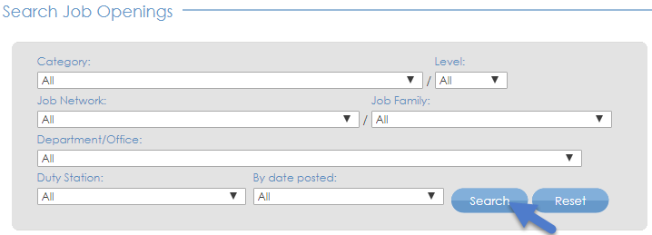 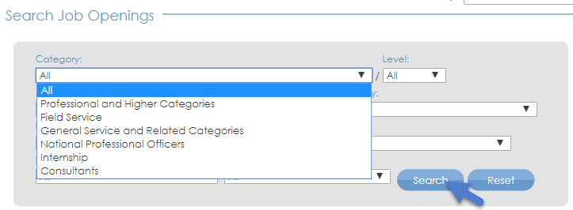

1. Click the job title to learn more about the position.

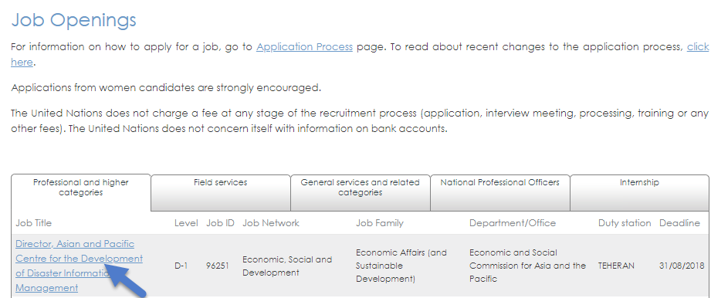

1. The United Nations Careers Portal is available in both English and French. Applicants can change the language by clicking *Français* or *English* on the top right side of the browser page.

inspira webpage screenshot of the link to change the language to French

Inspira:<https://inspira.un.org>

1. 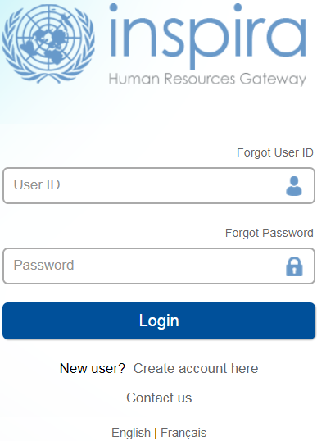To search job openings in Inspira, applicants need an account. If they already have an account, they may log in to Inspira by entering the username and password. Otherwise, applicants should create an account according to the instructions provided in **Chapter 2**.
2. Inspira is available in both English and French. Applicants can change the language by clicking *Français* or *English* below the login button.
3. After logging in, enter keywords such as job title or duty station in the search boxes to look for job openings (1 year or longer) or temporary job openings (less than 1 year). Click *Search*.

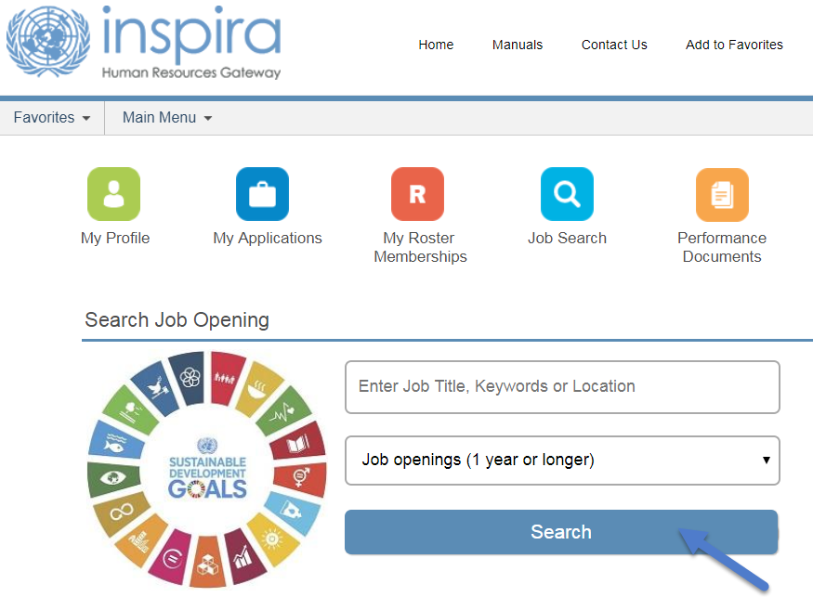

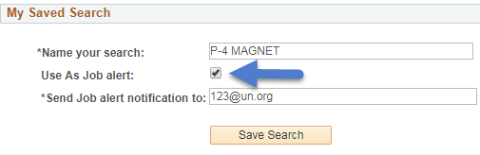

1. 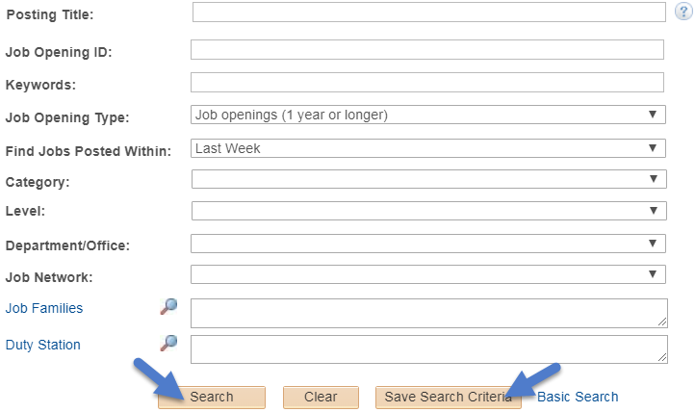For an advanced search, click *Job Search* at the top of the home page to search by keyword, category, level, time of posting, job network, job family and duty station. Click the job title to learn more about the position.
2. Applicants may click *Save Search Criteria* to keep the search results and receive notifications for new job openings matching the search criteria. When saving the search criteria, applicants will be asked to name the search. They may set up notifications by checking the box *Use As Job alert*. Once that has been done, click *Save Search*. Job alerts are not available for temporary job openings.
3. Applicants may view saved searches and job alerts by clicking *My Saved Searches & Job Alerts* link on the top of the *Job Search* page. Saved job criteria and job alerts are active for a period of six months.

inspira webpage screenshot of where to find the My Saved Searches & Job Alerts link

1. To mark specific job openings for later, applicants may click the star icon (star icon) on the far-right side of the searched job opening from the search list or in the title box after opening the job opening. Once the icon fills up in yellow (star icon), applicants may see the job openings again by clicking *My Favorite Jobs* at the top of the Inspira home page.



1. Notifications relating to job applications, job alerts, selections, etc. may be viewed by clicking *My Notifications* on the Inspira home page.

**Accessibility**

1. Accessibility features are available on both the United Nations Careers Portal and Inspira to assist persons with disabilities. This accessibility menu can be read by assistive screen readers (e.g. JAWS, NVDA).
2. 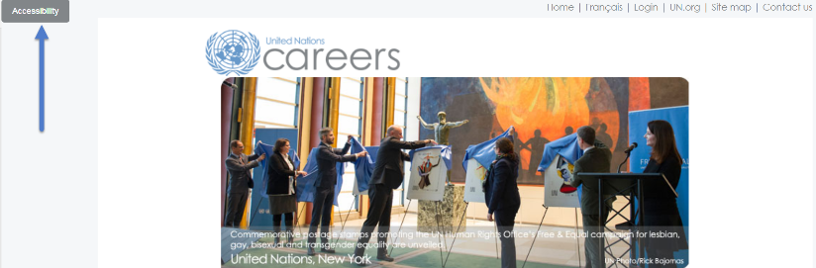To turn on the accessibility features, click the grey *Accessibility* button located on the upper-left side of the browser for the Careers Portal and at the bottom-right side of the browser for Inspira.
3. 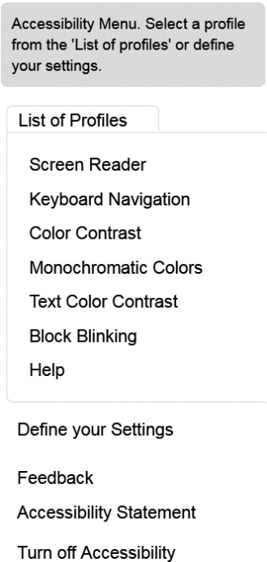Select an accessibility profile from the menu. The list of profiles includes: Screen Reader, Keyboard Navigation, Color Contrast, Monochromatic Colors, Text Color Contrast and Block Blinking. Once a profile is selected, the webpage will automatically refresh with the feature.

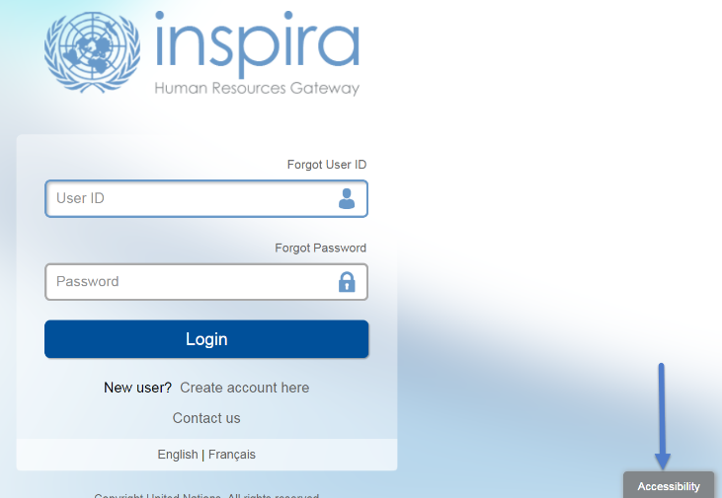

1. 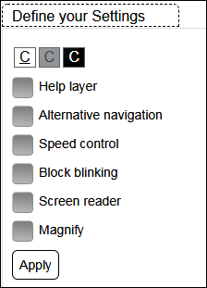Click on “Define your Settings” to choose colors (Normal, Grayscale, High Contrast) and other settings which include: Help Layer, Alternative navigation, Speed control, Block blinking, Screen reader, Magnify. After selecting the preferred options, click on the Apply button.

**Need help?**

1. Email Us buttonApplicants may seek assistance or send in any queries by clicking *Contact Us* located at the top of the Inspira landing page. On this page, applicants will find frequently asked questions (FAQs) per category and subcategory. Otherwise, applicants may submit a specific inquiry by clicking *Email Us.*

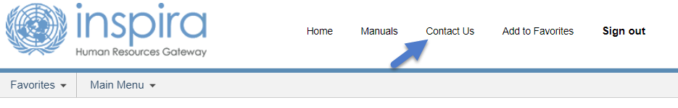

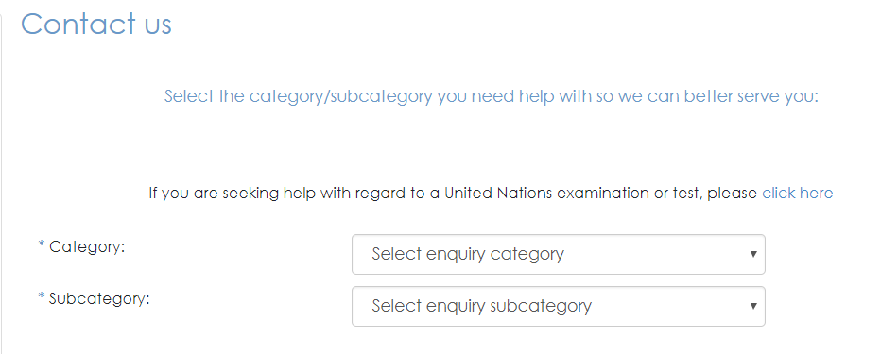

Chapter 2. Opening an Account

1. Applicants must have an account in Inspira, the United Nations’ talent management platform, to apply for job openings. Creating an account in Inspira is easy. Employees may also transfer previously acquired roster memberships to employee accounts in Inspira.

**Who needs to create an Inspira account?**

**Applicants other than United Nations Secretariat staff members**

1. Applicants need to create an account, unless they are staff members of the United Nations Secretariat or other United Nations and related organizations adopting Inspira as their talent management platform.

**Employee accounts for the United Nations staff members**

1. Staff members are issued employee accounts when they join the United Nations Secretariat. The same applies to staff members of other United Nations and related organizations adopting Inspira as their talent management platform.
2. The employee account information is sent to staff members via an automatic e-mail notification. Staff members are required to use this account to apply for job openings. Former staff members may continue to use these accounts following separation.

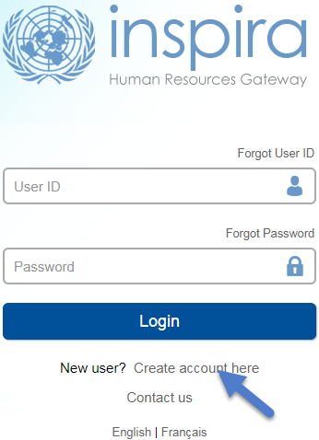**Creating an Inspira account**

1. Go to [https://Inspira.un.org](http://inspira.un.org) and click *Create account here*.
2. Enter the given and family name, password, primary e-mail and date of birth. Once the account is created, the date of birth cannot be changed.
3. Click *Register*. The system will automatically create a User ID. It will be e-mailed to the applicant, but it is advisable to write it down for ease of reference.

**Log in to Inspira and update profile information**

1. Once an account has been created or issued, enter the *User ID* and *Password* and click *Login*.
2. 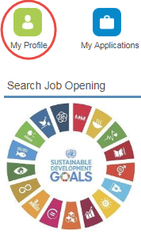For the first login, applicants should update their profile by clicking *My Profile* at the top of the Inspira home page. The mandatory fields of *My Profile* must be completed before submitting any application.
3. In *Nationality & Residence*, a copy of the personal details page of the applicant’s passport containing the photo and biographical data should be uploaded, unless the applicant is a current employee. If a passport is not readily available, the applicant may provide another travel document or photo ID.

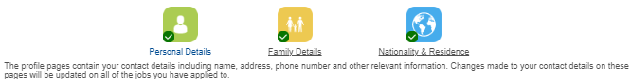

1. Applicants must ensure their contact information including telephone number, e-mail address and physical addresses are current. Hiring managers may try to reach them via phone and e-mail. Applicants may update their contact information by going to the following pages depending on the account type:

* External account holders: *My Profile > Personal Details*
* 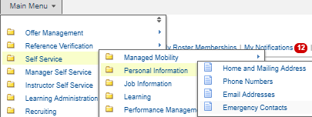Employee account holders: *Main Menu > Self Service > Personal Information*

Transferring roster membership from external account to employee account

1. To transfer roster memberships acquired on an external account to an employee account, in the employee account go to either 1) *Main Menu > Self Service > Transfer roster memberships*; or 2) *My Roster Memberships* and click *Transfer Roster Memberships*. Applicants should complete their employee account profiles prior to initiating the transfer and follow the instructions to verify that they are the owner of both accounts.
2. After transferring the roster memberships from an external account, applicants will not be able to submit new applications using the external account. This will not affect applications which have already been submitted from the external account prior to the transfer. Applicants will continue to receive status updates of the submitted applications in the external account. Any roster memberships subsequently obtained after the transfer in the external account will be automatically transferred to the employee account.
3. For external accounts with roster memberships, changes to the first name and given name are not possible. External account holders with roster memberships who wish to change their names in Inspira should raise a support ticket and provide documentation to evidence the name changes.

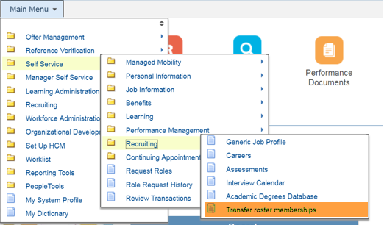

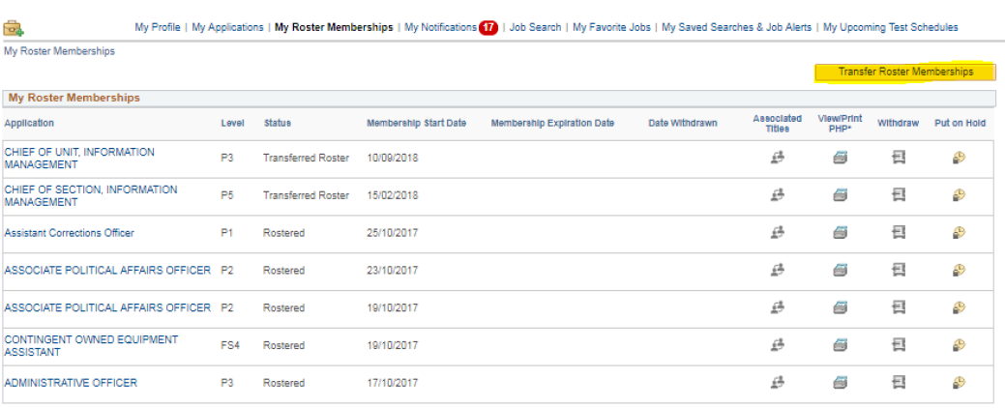

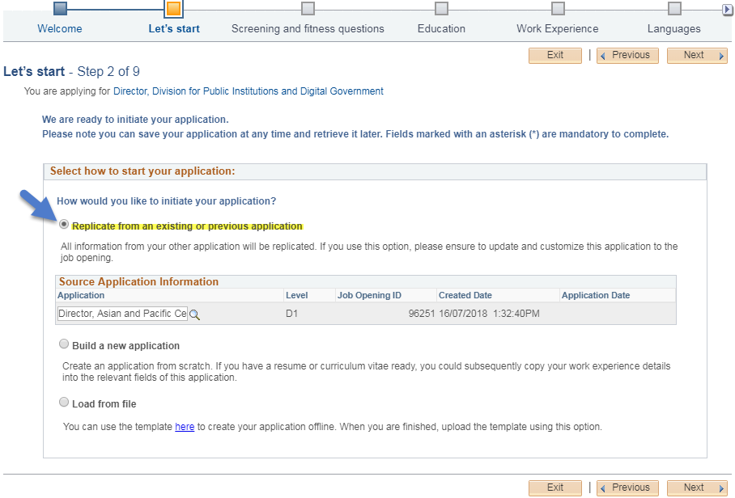Chapter 3: Applying to job openings

1. During the application process, applicants will be asked to provide details and documentation pertaining to their educational background, work experience, language proficiency and other qualifications, knowledge and skills. It is important for applicants to elaborate in the application that they satisfy the criteria specified in the job opening. The United Nations may screen applicants through automatic screening, manual review and other evaluation methods.

**Assessing qualifications**

1. Once applicants have found a job opening that interests them, they should pay special attention to the criteria specified for education, work experience, languages and competencies. Applicants are encouraged to apply for job openings for which they at least meet the “required” criteria and have previously demonstrated the specified competencies.
2. The criteria indicated as “required” are mandatory to be considered for the job opening. The criteria which are specified as “highly desirable” or “desirable” are not mandatory. However, some or all desirable criteria may be necessary for applicants to be shortlisted.
3. Applicants should also pay attention to the competencies stated in the job openings. Applicants may be assessed to determine if they have these competencies through different evaluation and assessment methodologies including a competency-based interview.

**Starting an application**

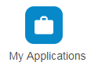

1. inspira webpage screenshot of the Create Draft Application buttonApplicants may create a draft application online which is not associated to a specific job opening in Inspira. Click *My Applications* on the top of the Inspira home page, and then click *Create Draft Application* on the upper right-hand side.
2. To start applying for a specific job opening, click *Apply Now* from the job opening in the United Nations Careers Portal or Inspira. Applicants may replicate a draft or submitted application, and update the information carried over from that application to create new applications tailored to the specific job openings they are applying for.
3. Applicants who do not have stable internet connection and are unable to complete their application online may fill out the application offline first and load the application by following paragraphs 68 to 71.
4. Applicants, especially rostered candidates, are encouraged to apply early. Job openings advertised to fill specific positions may be filled with rostered candidates who are preapproved for selection during the posting period. No application will be received following the posting period of the job opening.
5. Applicants accessing Inspira from the United Nations Careers Portal will be required to log into Inspira. Applicants who do not have an account must create an account according to **Chapter 2**.

**Application snapshot**

1. The application process consists of the following steps. Applicants must fill all fields marked with an asterisk (*). Applications should be saved at each step of the process so that the information can be retrieved later.

|  |  |
| --- | --- |
| **Steps** | **Description** |
| **1. Welcome** | Let us know how you learned about the job opening. |
| **2. Let’s start** | Decide whether you want to create your application from scratch; replicate a draft or previous application; or use an offline template. |
| **3. Screening questions** | Answer a series of questions to help us identify candidates who meet the criteria specified in the job opening. |
| **4. Education** | Provide information about your university degrees and high school diploma. |
| **5. Work experience** | Provide information about your work experience and supervisors. |
| **6. Languages** | Indicate your languages skills, especially your proficiency level in the working languages of the Secretariat (English and French) including your mother tongue. |
| **7. Skills & Training** | Add trainings that you have taken including certificates and diplomas. Add any publications. |
| **8. Cover Letter** | Include your cover letter and provide professional references for reference checking especially if you have had less than three supervisors. Upload performance evaluation reports, degree certificate, high school diploma, transcripts, etc. Answer mandatory questions. |
| **9. Review your application** | Review all information added in the application before clicking *Submit Application*. |
| **10.Confirm and submit** | Review the Terms and Agreements and click *Certify and Submit Application*. |

**Filling out the application**

**Screening questions**

1. These are specific questions relating to the criteria specified in the job opening for identifying candidates who meet them. The question responses should be supported by details provided in the rest of the application including for education qualifications, work experience and language fluency.

**Education**

1. 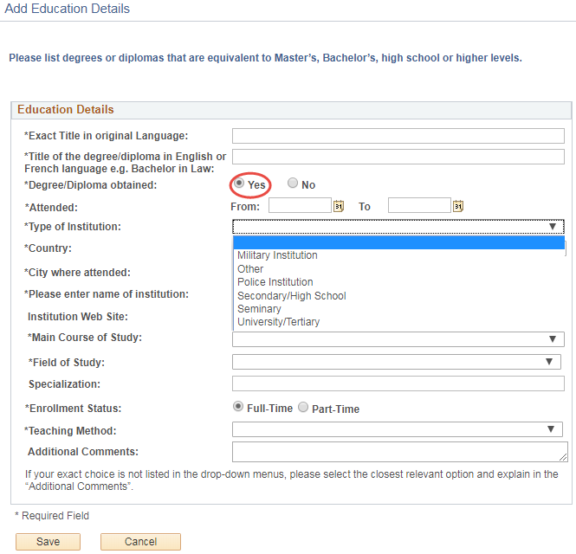Applicants should list high school diplomas and university degrees equivalent to Bachelor’s, Master’s or Doctorate degrees. To add a high school diploma or degree, click on *Add Education Details* in the *Education* section of the application and fill out the fields. Applicants who have completed and been conferred a high school diploma or a degree should provide the details of these qualifications and indicate that the diploma or degree was “obtained.”
2. High school diploma and degrees must be issued by academic institutions which are accredited to issue them by the competent authorities where the institutions are based. The ultimate decision on their recognition and equivalency is made by the United Nations upon the review of the nature, level, context and content of the education programme and accreditation status of the issuing institution.
3. 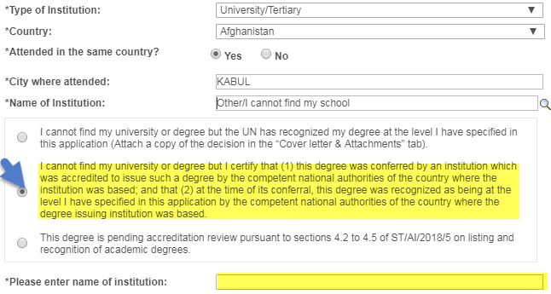Many universities and degrees are searchable from the preloaded database in the application form. In case a university or degree cannot be found and the United Nations has not otherwise recognized the degree, applicants should confirm the accreditation status of the institution and degree through the institution itself and the appropriate ministry of education and accreditation bodies. After confirming that the institution is accredited to issue the specific degree, applicants may list the degree by selecting “Other/I cannot find my school” in the field for *Name of Institution*. Applicants should then select the second option from the dropdown, as shown below, and manually enter the name of the institution.
4. Applicants should attach a soft copy of the degree certificates, transcripts and other supplementary materials supporting the level and accreditation status of the degrees listed in their application in the *Cover Letter* section. This especially applies to applicants who are not staff and who are not holding a permanent, continuing or fixed-term appointment with the United Nations.
5. Short-term certificates or diplomas which are not equivalent to a high school diploma, or Bachelor’s, Master’s, Doctorate degree or equivalent should not be listed under *Education*. They may be included in the *Skills & Training* section.

**Work experience**

1. In the *Work Experience* step of the application, click *Add Work Experience*. Proceed to fill the information in the entry form. Include all relevant work experience in the application.

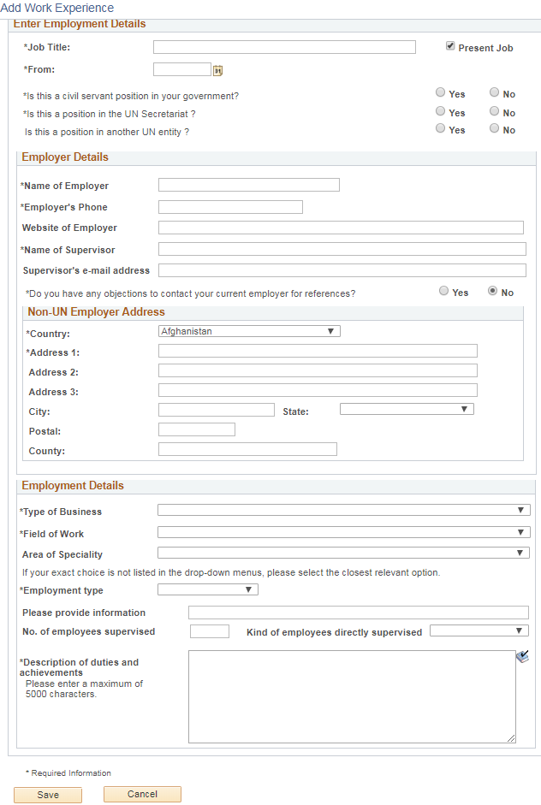

1. In the *Description of duties and achievements* field, applicants should make sure to describe the duties followed by related achievements. This is the opportunity for applicants to elaborate on how they meet the work experience criteria of the job opening.
2. Applicants should provide the contact information of their employers and supervisors. The United Nations may contact them for employment record verification and qualitative reference checks. If the applicants do not wish the United Nations to contact their current employer and supervisor, they may so indicate for the current work experience. However, if they are selected for a job opening, their current employer and supervisor will be contacted.

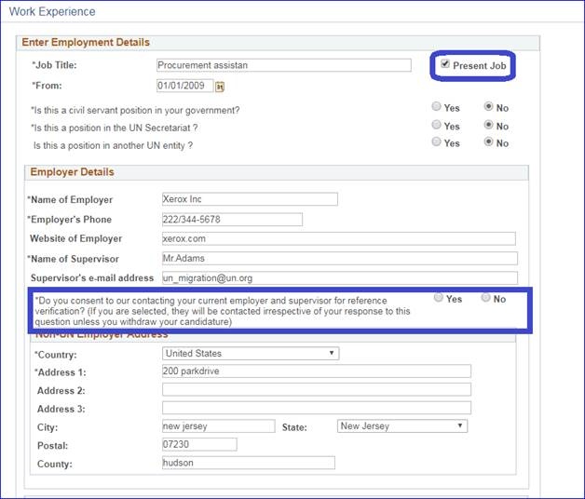

**Languages**

1. Applicants should remember to indicate their proficiency level for the languages specified in the job opening including their mother tongue. Applicants will not be considered for job openings if they do not indicate proficiency in the required languages. Generally, fluency in either English or French, the two working languages of the United Nations Secretariat, is required for any job openings.

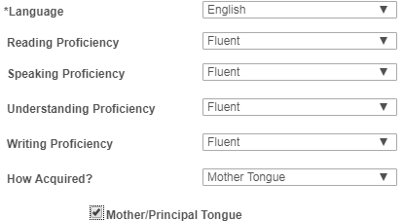

1. To be considered fluent in a language, the proficiency level in all four specified areas (i.e. reading, speaking, understanding and writing) must be “fluent.” To be considered to have knowledge in a language, the proficiency level in at least two out of the four specified areas must be “confident” or “fluent.”

**Skills & Training**

1. In this section, applicants may list:

* Short-term certificates or diplomas which are not equivalent to Bachelor’s, Master’s, Doctorate or equivalent degrees
* Licenses and professional certificates (e.g. Certified Public Accountant – CPA)
* Publications (e.g. books, articles, journals and reports)

**Cover letter**

1. A cover letter should be brief and targeted to the job opening that applicants are applying for. The cover letter should highlight their most relevant experience, qualifications and competencies. It should also demonstrate the applicants’ suitability for the position and how they can contribute to delivering the team’s mandates and goals.

**References**

1. 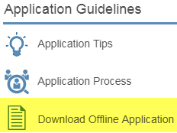The United Nations seeks professional reference mainly from the applicants’ supervisors. Applicants who have had a relatively short career and less than three supervisors may include other professional referees such as professors, thesis advisors, mentors, colleagues, clients or other persons with whom they have had professional relationships.

**Submitting the application**

1. Applicants should review their application carefully before submitting it. Once the application has been submitted, applicants will not be able to make changes to it. They may withdraw an application, but they cannot apply to the same job opening again.
2. Applicants give consent to reference verification at the time of submitting the application. The United Nations and its authorized service providers may contact the academic institutions, employers, supervisors, references, organizations of the United Nations system and other international organizations and governments, and investigate if the applicants meet the highest standards of efficiency, competence and integrity standards required for employment with the United Nations. When applicants specifically express their consent to contacting the current employer and supervisor in the application, they may be contacted at any stage of the recruitment process. Selected applicants may not have the option of opting out of reference verification with the current employers and supervisors.
3. If applicants need to update their profile, they may save the application and go to *My Profile*. After they have updated their profile, they may retrieve the application by clicking on *My Applications* in the Inspira home page.

**Using offline application**

1. While it is easier to fill out the application online, applicants who do not have stable internet connection may use the offline application form. As the first step, applicants should download the latest version of the template. Only the latest version can be uploaded back to Inspira.
2. To start an offline application, applicants should create a draft application or an application for a specific job opening, and in step 2 of the application process (*Let’s start*), download the Offline Application Template. Alternatively, applicants can download the template through a link located at the bottom of the Inspira home page.
3. 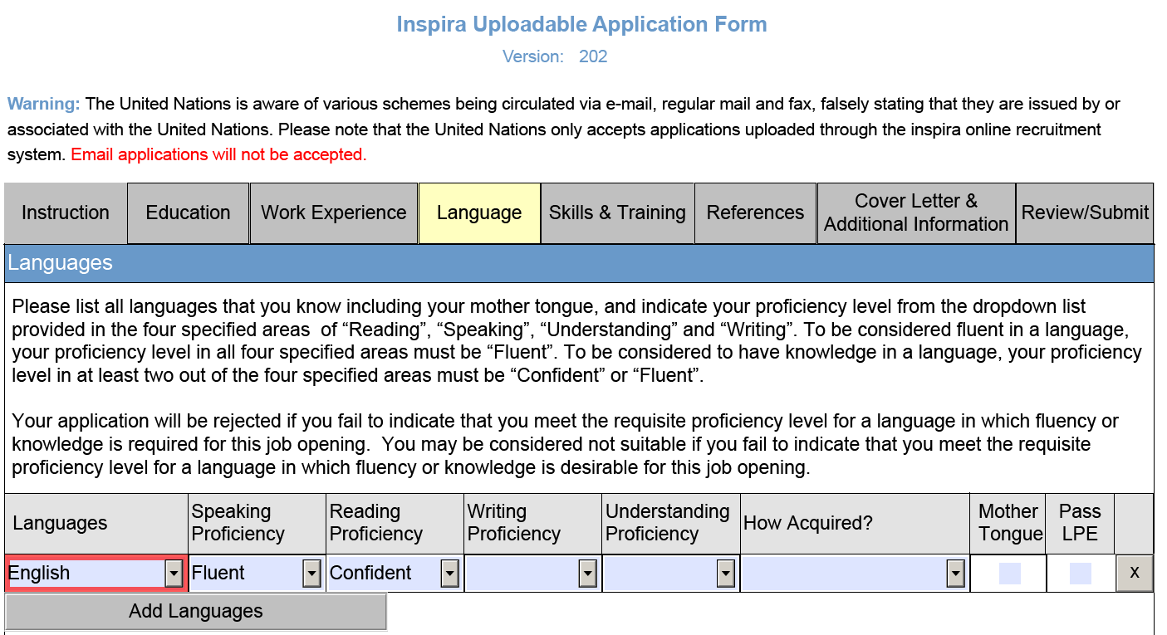Follow the instructions provided in the offline application template and fill out the form.
4. 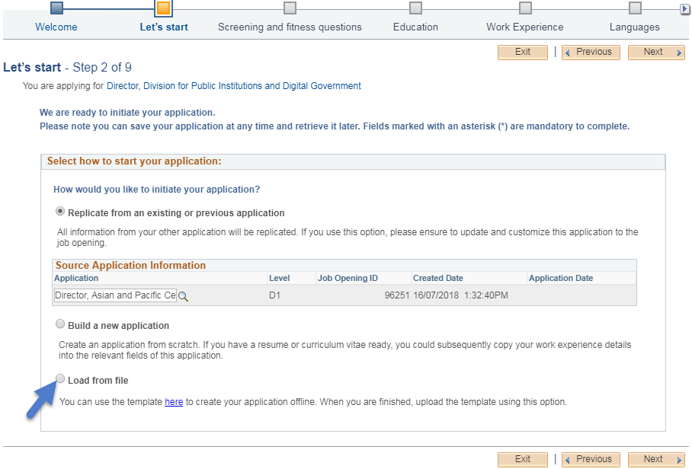While applying for a job opening, choose the “Load from File” option at the second step of the application process (*Let’s start*). Once the template has been uploaded, complete the remaining process to submit the application.

Chapter 4: Evaluation and assessment

1. After submitting the application, applicants may go through various stages of evaluation and assessment.

**Automatic and manual screening**

1. Upon submission, applications go through an automatic screening process in Inspira based on a set of pre-established rules on age, academic qualifications, length of work experience, family relationships, criminal record and others according to the United Nations Staff Regulations and Rules, applicable policies and requirements of the job opening. In some cases, the United Nations may conduct manual reviews requiring applicants to respond in a timely manner.

**Evaluation**

1. The hiring managers evaluate the released applicants and create a shortlist of applicants based on the criteria specified in the job opening.

Assessments

1. Shortlisted applicants may be invited to participate in assessments such as written exercises, presentations, technical tests, knowledge-based interview, competency-based interviews or other assessments.
2. Assessments are normally scheduled for a specific date and time slot. Applicants who do not respond to invitations or cannot be reached by e-mail or phone in a timely manner, or do not participate in assessments will be disqualified.
3. Applicants should follow all instructions. Failing to do so including missing the deadline for submitting the response may lead to disqualification. Cheating will immediately disqualify the applicants from further consideration.

**Competency-based interviews**

1. For job openings and generic job openings, the competency-based interview is a mandatory assessment methodology. Only a select number of applicants are invited for this interview. The goal of this interview is to gather objective evidence of the applicants’ competencies through their past behaviour and performance.
2. Before the interview, applicants should familiarize themselves with the indicators of each competency stipulated in the job opening and think about the past examples where they demonstrated those indicators.
3. During the interview, the interview panel normally consisting of three United Nations staff members including the hiring manager, will ask for examples when they have demonstrated the competencies, particularly how they handled or addressed a situation or task. Applicants may be asked to give both positive and negative examples for some of the competencies. These questions are called behavioural questions. Appraisal and comparison questions may be used to obtain further insight on the applicant’s behaviours. Several probing or follow-up questions may also be asked until the interview panel has gathered sufficient evidence.
4. The below table shows some examples of different question types which are asked during a competency-based interview:

|  |  |
| --- | --- |
| **Behavioral** | * Give me an example of… * Please describe a situation when you had to… and how did you go about it? |
| **Appraisal** | * What was the feedback you received from your team members? * What feedback did you receive about your role in this project? |
| **Comparison** | * In relation to leadership specifically, what makes you stand out as compared to others around you? * Which of your previous experiences working in a team was the best as compared to others, and why? |
| **Probing/**  **follow-up** | * What happened next? * What were your specific responsibilities in the team? |

1. A competency-based interview typically lasts 30 to 60 minutes. Depending on the location of the applicant and availability of communication methodologies, a mix of in-person, video or phone interviews may occur.

Chapter 5: Application results and roster placement

Checking application status

1. Applicants may check the status of their application in Inspira by clicking *My Applications*. Each status has the following meaning:

* *Draft* means the applicant has started a draft application but has not submitted it.
* *Applied* means the applicant has just applied to the job opening and the application is being screened through Inspira.
* *Under Consideration* means the application has been screened by Inspira, and the recruitment process is on-going.
* *Recruitment Completed* means the process has been completed with the selection of another applicant.
* *Rostered* means the applicant was recommended for the job opening although he or she was not selected.
* *Selected* means the applicant was selected for the job opening.
* *Filled from Roster* meansa rostered applicant was selected.
* *JO Cancelled* means the job opening was cancelled.

Application result: Selected

1. Applicants who are selected for job openings are notified immediately. Selected applicants must confirm their continued interest and availability via e-mail within five business days of the notification. If no confirmation is received within five business days, another applicant may be selected.

**Application result: Rostered**

1. All applicants who are recommended for selection and roster placement for job openings and generic job openings, including the selected applicants, are placed on the roster, which is a pool of preapproved candidates for subsequent job openings at the same level and with similar functions. However, placement on the roster is no guarantee of a future selection or appointment. The scope of the roster may change as determined appropriate by the United Nations Office of Human Resources in the Department of Management Strategy, Policy and Compliance.
2. Roster candidates receive an invitation to apply when job openings are advertised where they are preapproved for selection. Roster candidates are encouraged to apply as early as possible because the hiring managers may immediately recommend roster candidates for selection without the full evaluation and assessment process.
3. 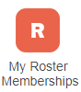To view roster memberships and details including the level, status, membership start date and associated job titles, click *My Roster Memberships* at the top of the Inspira home page. Candidates may withdraw from the roster or put their roster membership on hold on this page. Once candidates withdraw themselves from a roster, the roster membership cannot be reinstated.
4. In *My Roster Memberships* page, applicants will also see currently available job openings to which they may apply as roster candidates.

